Assignment 2

Part 1 - Basic description of language development

**- Describe your sample (n, age, gender, clinical and cognitive features of the two groups) and critically assess whether the groups (ASD and TD) are balanced**

The sample included 61 participants. 29 of these were with Autism Spectrum Disorder(ASD) with a mean age of 33 months, and 32 were typical development (TD) with a mean age of 20.4 months. Both groups consisted mainly of women.

ASD participants had a mean verbal IQ of 17.31 and TD participants had a mean verbal IQ of 20.22. Mean non-verbal IQ was 26.89 for ASD and 26.00 for TD.

**- Describe linguistic development (in terms of MLU over time) in TD and ASD children (as a function of group).**

We made the following plot showing the mean length of utterances as a function of visit number for each group**:**

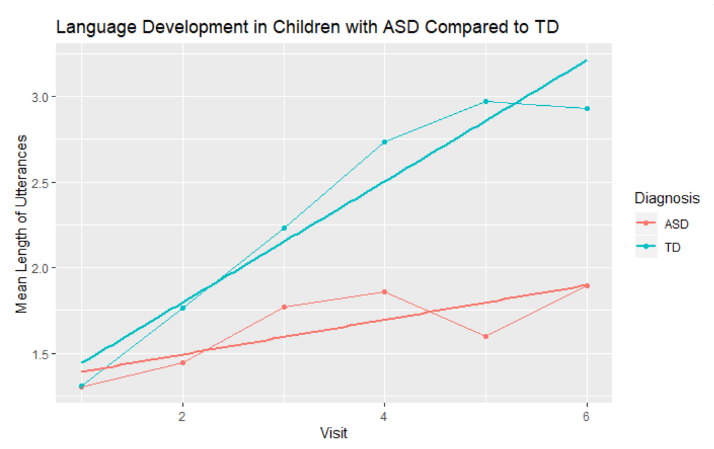

Here we see that children with ASD and TD start out with approximately the same mean length of utterances. Over time the TD children develop much faster than the ASD children.

We included a regression line as well as a line plot reflecting the mean length of utterances at each visit to clarify the development.

We make the following linear mixed-effects model:

$Mean length of utteranc{es}_{ Child}$ ~ $Visit * Diagnosis + (1+Visit|Subject)$

CHI_MLU was found to be significantly predicted by the interaction of visit and diagnosis with beta = 0.25, (SE = 0.04), t = 6.7, p < 0.01.

Linguistic development of children MLU is affected by the interaction of visit and diagnosis with random effects including random intercepts for subjects as well as by-visit random slopes for the effect of the interaction of visit and diagnosis.

**- Describe how parental use of language (in terms of MLU) changes over time. What do you think is going on?**

We made the following visualization of the data:

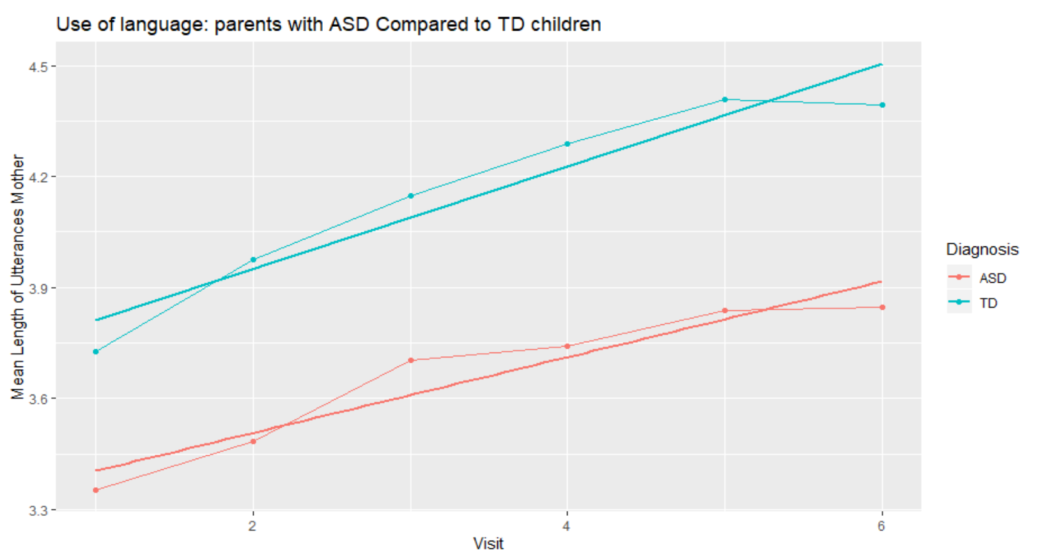

Here we see that the slopes for both parents of ASD and TD children progress similarly, but differ in their intercepts. Parents of ASD children have a shorter mean length of utterances at the first visit compared to parents of TD children. But the changes over time are similar across the two groups.

Mean length utterance of parents was found to be significantly predicted by the visit and diagnosis with a significant main effects of visit with beta = 0.12., (SE = 0.02), t = 6.54, p < .1 and diagnosis beta = 0.50, (SE = 0.12), t = 4.36, p < 0.01.

Unlike the CHI_MLU there was no significant interaction effect between visit and diagnosis.

Linguistic development of the mother MLU is affected by visit and diagnosis with random effects including random intercepts for subjects as well as by-visit random slopes for the effect of the visit and diagnosis.

**- Include individual differences in your model of language development (in children). Identify the best model.**

We used the Step function, where we added all individual differences variables.

We found the best model to be:

$Mean length of utteranc{es}_{ Child}$ ~ $Visit * Diagnosis +Verbal IQ_{Visit1}+ (1+Visit|Subject)$

CHI_MLU was found to be significantly predicted by Verbal IQ from the first visit and the interaction of the visit and diagnosis with beta = 0.26., (SE = 0.04), t = 6.72, p < .01.